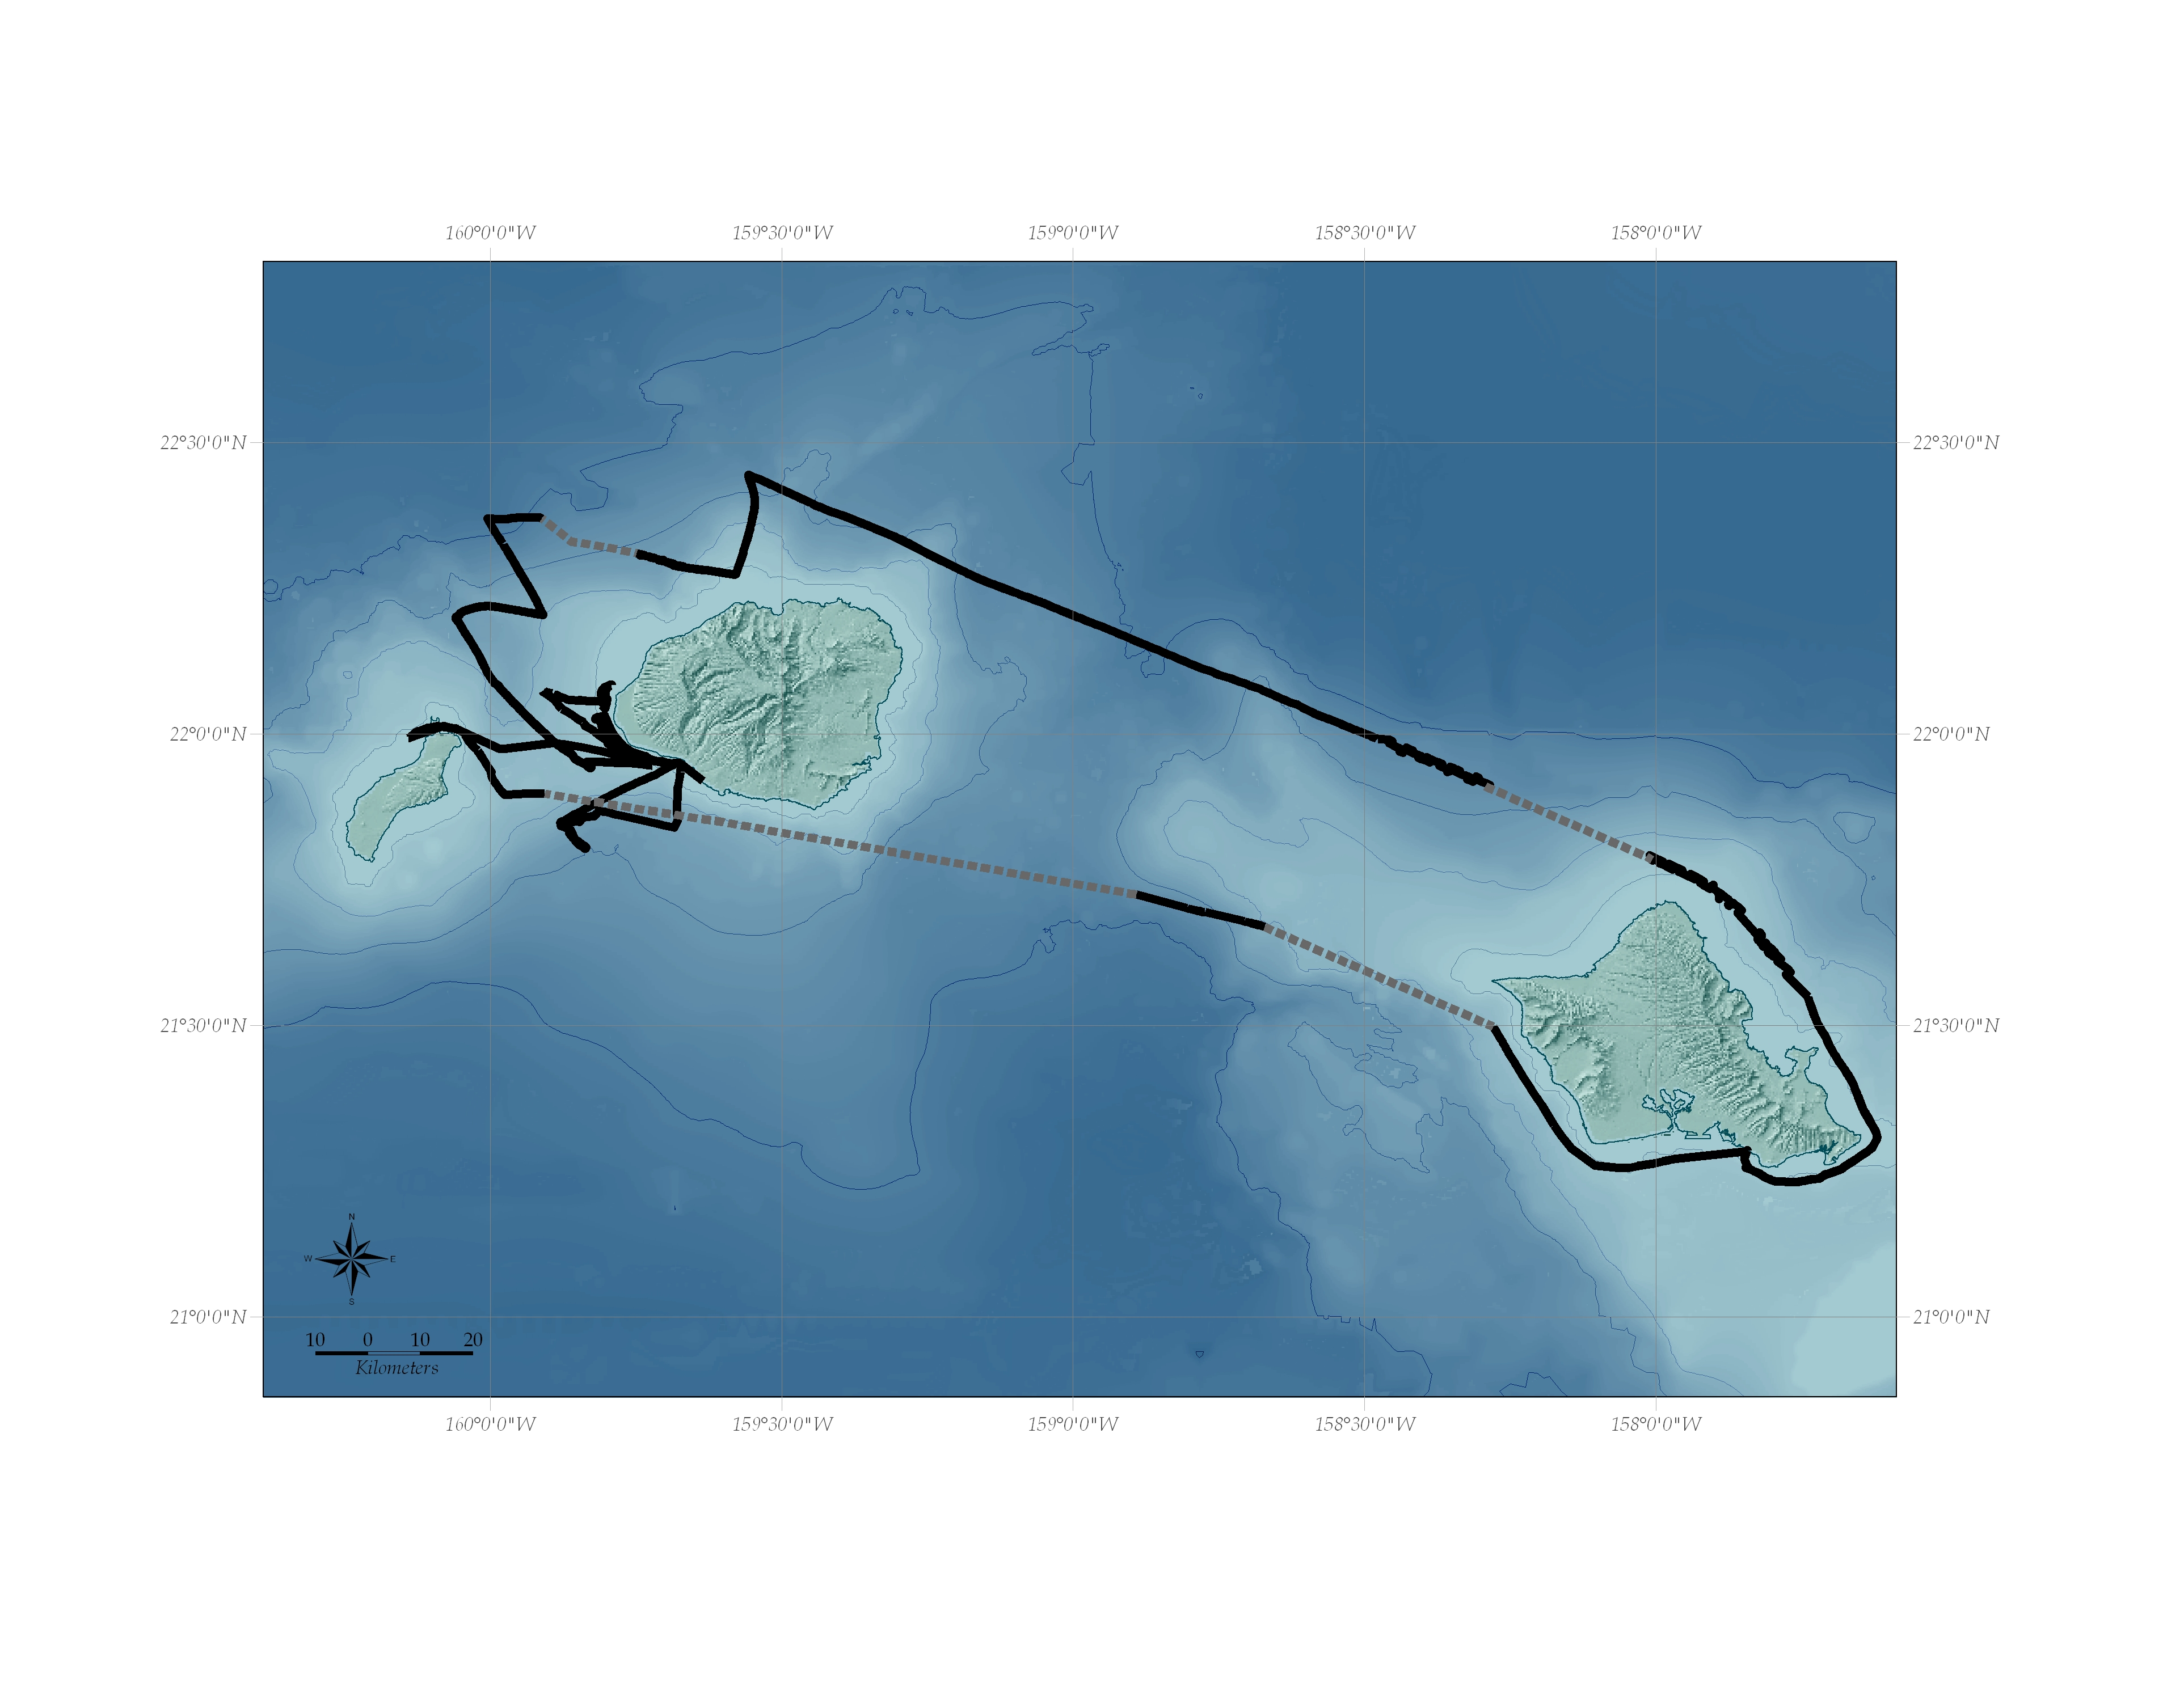
700 fm.
1400 fm.
100 fm.
700 fm.
2100 fm.
2100 fm.
100 fm.
1400 fm.
Known Tracks
Estimated Tracks

Night-time transit
(no GPS record)
Figure 1. R/V Dariabar tracks during the Ni’ihau-Kaua’i-O’ahu cruise 17-24 February 2005. Dashed grey lines indicate periods with limited or no GPS record.

